ONLINE SHOPPING CART



A Course Project Report in the course

Problem Solving with Programming

**Computer Science & Engineering (AI & ML)**

**By**

Roll.No:2103A52039 Name: V. AKSHAY KUMAR

Roll.No:2103A52155 Name: M. ABHAY RAJ

Roll.No:2103A52134 Name: G. SRAVYA

Roll.No:2103A52129 Name: CH. KEERTHANA

Roll.No:2103A52113 Name. V.VENKAT REDDY

Roll.No:2103A52138 Name: A. UDAYSAI

**Under the Guidance of**

Dr. M Sheshikala

Assoc. Prof& Head

**Submitted to**

**June, 2022**





PSP- COURSE PROJECT

ONLINE SHOPPING CART

SECTION-H2 (BATCH-01)

|  |  |
| --- | --- |
| CONTENTS | Page.No |
| 1. ABSTRACT 2. PROJECT REQUIRMENTS 3. PROJECT DOCUMENTATION 4. CODE 5. OUTPUTS | 4-5  6  7-8  9-22  23-27 |



**DEPARTMENT OF COMPUTER SCIENCE AND ARTIFICIAL INTELLIGENCE**

**CERTIFICATE**

This is to certify that the Course Project Report entitled “ ONLINE SHOPPING CART “ is a record of bonafide work carried out by the student(s) V. Akshaykumar, G.Sravya, M.Abhay Raj, Ch.Keerthana, V.Venkatreddy, A.Udaysai bearing Roll No(s): 2103A52039, 2103A52134, 2103A52155, 2103A52129, 2103A52113, 2103A52138 during the academic year 2021-22.

**Supervisor Head of the Department**

**External Examiner**

**ONLINE SHOPPING CART**

ABSTRACT:

**ONLINE SHOPPING**



An online shopping cart is software that makes it possible for customers to select products and buy them online. The system helps in buying of products online by choosing the listed products from the website (E-Commerce site).This application provides an ease to buy some products and do some sort of operations like create account, adding more quantity of products, deleting of product from cart, completing payment and accessing the stock information of the shopping mart. This shopping cart and order management system is a simple web application that acts as an online store users can visit on the internet. Here, customers can surf through the available stock or inventory in the website, select the items of their choice, and add them to cart for purchasing. The user can then view the complete specification of each product. The application also

provides a drag and drop feature so that a user can add a product to the shopping cart by dragging the item in to the shopping cart.

For shopping the customer need to provide the following details:

* Name of the customer
* Complete address details
* Phone no
* Mail id

Firstly a menu will be displayed to the customer. After the selection, all the products with their prices will be displayed. Then the customer will select the products and chooses the quantity (number of products). This process continues until the shopping is completed. Whenever the customer completes his shopping, the items, quantity, cost, and finally the total amount to be paid are displayed. All the shopping cart bill are calculated from the system. In order to make it simple, we have developed a code using c programming language.

Structures and function have been used in this code. This code provides simplest and the best way to calculate the bill of the customer

This code includes:

* Quantity function.
* Bill function.
* Delete function.

PROJECT REQUIREMENTS:

HARDWARE:

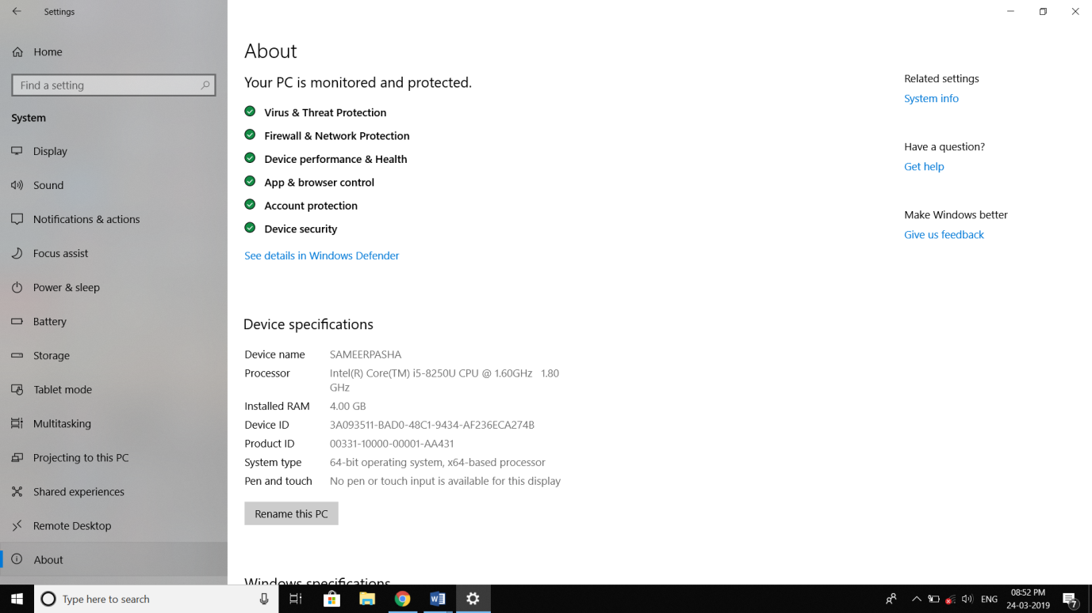

SOFTWARE: DEV C++

+

Dev-C++ is a free full-featured integrated development environment distributed under the GNU General Public License for programming in C and C++. It is written in Delphi. It is bundled with, and uses, the Min GW or TDM-GCC 64bit port of the GCC as its compiler.

[**Written in**](https://www.google.com/search?safe=active&rlz=1C1NDCM_enIN810IN811&q=dev-c%2B%2B+written+in&stick=H4sIAAAAAAAAAOPgE-LUz9U3MIrPSLfQUsoot9JPzs_JSU0uyczP0y_OTyspTyxKtSovyiwpSc1TyMxbxCqUklqmm6ytrYAQBAAN8MdcRgAAAA&sa=X&ved=2ahUKEwj4qKqaxZ3hAhWe7HMBHQBUCGEQ6BMoADAlegQICxAG)**:**[Object Pascal](https://www.google.com/search?safe=active&rlz=1C1NDCM_enIN810IN811&q=Object+Pascal&stick=H4sIAAAAAAAAAOPgE-LUz9U3MIrPSLdQgjArs9LjtZQyyq30k_NzclKTSzLz8_SL89NKyhOLUq3KizJLSlLzFDLzFrHy-idlAeUVAhKLkxNzAJ7Mls1MAAAA&sa=X&ved=2ahUKEwj4qKqaxZ3hAhWe7HMBHQBUCGEQmxMoATAlegQICxAH)

[**Developer(s)**](https://www.google.com/search?safe=active&rlz=1C1NDCM_enIN810IN811&q=dev-c%2B%2B+developers&sa=X&ved=2ahUKEwj4qKqaxZ3hAhWe7HMBHQBUCGEQ6BMoADAmegQICxAK)**:**Bloodshed Software until 2005, Orwell (Johan Mes) since 2011

[**License**](https://www.google.com/search?safe=active&rlz=1C1NDCM_enIN810IN811&q=dev-c%2B%2B+license&sa=X&ved=2ahUKEwj4qKqaxZ3hAhWe7HMBHQBUCGEQ6BMoADAnegQICxAN)**:**[GNU General Public License](https://www.google.com/search?safe=active&rlz=1C1NDCM_enIN810IN811&q=GNU+General+Public+License&stick=H4sIAAAAAAAAAONgVuLQz9U3MDZPzl3EKuXuF6rgnpqXWpSYoxBQmpSTmazgk5mcmlecCgBHUHbrKQAAAA&sa=X&ved=2ahUKEwj4qKqaxZ3hAhWe7HMBHQBUCGEQmxMoATAnegQICxAO)

[**Stable release**](https://www.google.com/search?safe=active&rlz=1C1NDCM_enIN810IN811&q=dev-c%2B%2B+stable+release&sa=X&ved=2ahUKEwj4qKqaxZ3hAhWe7HMBHQBUCGEQ6BMoADAoegQICxAR)**:**5.11 / [April 27, 2015](https://www.google.com/search?safe=active&rlz=1C1NDCM_enIN810IN811&q=April+27,+2015&stick=H4sIAAAAAAAAAONgVhLQL9E3MjExz6gwLC9PqUrJXsTK51hQlJmjYGSuo2BkYGgKALPTU2glAAAA&sa=X&ved=2ahUKEwj4qKqaxZ3hAhWe7HMBHQBUCGEQmxMoATAoegQICxAS); 3 years ago.

[**Operating system**](https://www.google.com/search?safe=active&rlz=1C1NDCM_enIN810IN811&q=dev-c%2B%2B+operating+system&sa=X&ved=2ahUKEwj4qKqaxZ3hAhWe7HMBHQBUCGEQ6BMoADApegQICxAV)**:**[Microsoft Windows](https://www.google.com/search?safe=active&rlz=1C1NDCM_enIN810IN811&q=Microsoft+Windows&stick=H4sIAAAAAAAAAONgVuLQz9U3MCmKt1jEKuibmVyUX5yfVqIQnpmXkl9eDABrmtGqIAAAAA&sa=X&ved=2ahUKEwj4qKqaxZ3hAhWe7HMBHQBUCGEQmxMoATApegQICxAW), [Linux](https://www.google.com/search?safe=active&rlz=1C1NDCM_enIN810IN811&q=Linux&stick=H4sIAAAAAAAAAONgVuLUz9U3SCuoqipYxMrqk5lXWgEATgerNhUAAAA&sa=X&ved=2ahUKEwj4qKqaxZ3hAhWe7HMBHQBUCGEQmxMoAjApegQICxAX) (alpha only)

Project Documentation:

In this code we have used functions, structures and files:

**Functions:**

* There several advantages of using functions in our code.
* It enhances the readability of a program.
* Usage functions in our code made easy to understand.
* It reduces the complexity of a program and gives it a modular structure.
* By implementing functions and procedures in this program, the programmer reduces coding time and debugging time, thereby reducing the overall development time.

The following are the functions implemented in our course project:

**1. Add function ( )** is used to add the extra items to the previous items in the cart. This function works when we press 1 when necessary.

**2. Delete function ( )** is used to delete the items from the cart.

It asks the id number of the product and deletes the product from the cart. This function works when we press 2 when necessary.

**3. Quantity function ( )** is used to modify the quantity of the existing product in the cart. This function works when we press 3 when necessary.

**4. Bill function ( )** is used to print details of all will be displayed along with bill. This function works when we press 4 when necessary.

**Files:**

File is created for permanent storage of data. If we want to enter a large amount of data normally, it takes a lot of time to enter them all. If we have a file containing all the data, we can easily access the contents of the file by using few commands in C. We can easily move

our data from one computer to another without changes.

In our project we have created a file automatically which stores the customer’s cart items which customer wants to buy.

**Structures:**

Structure is a user-defined data type in C language which allows us to combine data of different types together. Structure helps to construct a complex data type which is more meaningful. It is useful in storing or using information or databases.

In our project we have created a product structure which contains complete details of a product like product id, product name, quantity and amount of the product.

CODE:

#include<stdio.h>

#include<string.h>

#include<stdlib.h>

#include<conio.h>

struct account

{

char name[20];

char address[40];

long long int pin;

long long int mobno[10];

char mailid[100];

}s;

struct cart

{

int sno;

char item[15];

int q;

int cost;

};

static int totalCost;

main()

{

static int a[20];

int k,c=1,i,j,acc,l=0;

char name[20];

char items[15][150]={"Sandisk_16GB ","Mouse ","Keyboard ",

"Adidas ","Nike ","Puma ",

"iPhone_13 ","Samsung_A52 ","Oneplus_Nord2 ",

"Zara ","Dnmx ","Netplay ",

"Dell_Inspiron ","Mac_Book ","Lenovo_Thinkpad"};

int cost[15]={350,300,450,

3550,5000,2800,

119900,29999,45000,

3549,2399,1299,

72000,129900,55000};

do

{

if(c==1)

{

if(l==1)

system("cls");

printf("Enter\n1 - Computer Accessories\n2 - Shoes\n3 - Mobiles\n4 - Shirts");

printf("\n5 - Laptops\n\nAny other number to exit\n");

printf("\nEnter number --->");

scanf("%d",&c);

switch(c)

{

case 1:

{

int c1;

printf("Enter\n1 - Sandisk 16 GB - Rs.350\n2 - Mouse - Rs.300\n");

printf("3 - Keyboard - Rs.450\n\nOther number to exit this category\n");

printf("\nEnter number --->");

scanf("%d",&c1);

switch(c1)

{

case 1:

{

int n;

printf("You have chose Sandisk 16GB with Rs.350.Are you sure to buy.If 'Yes' Enter 1 else any number\n");

scanf("%d",&n);

if(n==1)

{

a[0]++;

totalCost+=350;

}

printf("Your Cost in Cart is %d\n",totalCost);

break;

}

case 2:

{

int n;

printf("You chose Mouse with Rs.300.Are you sure to buy.If 'Yes' Enter 1 else any number\n");

scanf("%d",&n);

if(n==1)

{

a[1]++;

totalCost+=300;

}

printf("Your Cost in Cart is %d\n",totalCost);

break;

}

case 3:

{

int n;

printf("You chose Keyboard with Rs.450.Are you sure to buy.If 'Yes' Enter 1 else any number\n");

scanf("%d",&n);

if(n==1)

{

a[2]++;

totalCost+=450;

}

printf("Your Cost in Cart is %d\n",totalCost);

break;

}

default:

{

printf("Exit from Computer Accesories\n");

break;

}

}

break;

}

case 2:

{

int c2;

printf("Enter\n1 - Adidas - Rs.3550\n2 - Nike - Rs.5000\n3 - Puma - Rs.2800\n\nOther number to exit this category\n");

printf("\nEnter number --->");

scanf("%d",&c2);

switch(c2)

{

case 1:

{

int n;

printf("You chose Adidas Shoes for Rs.3550.Are you sure to buy.If 'Yes' Enter 1 else any number\n");

scanf("%d",&n);

if(n==1)

{

a[3]++;

totalCost+=3550;

}

printf("Your Cost in Cart is %d\n",totalCost);

break;

}

case 2:

{

int n;

printf("You chose Nike Shoes for Rs.5000.Are you sure to buy.If 'Yes' Enter 1 else any number\n");

scanf("%d",&n);

if(n==1)

{

a[4]++;

totalCost+=5000;

}

printf("Your Cost in Cart is %d\n",totalCost);

break;

}

case 3:

{

int n;

printf("You chose Puma Shoes for Rs.2800.Are you sure to buy.If 'Yes' Enter 1 else any number\n");

scanf("%d",&n);

if(n==1)

{

a[5]++;

totalCost+=2800;

}

printf("Your Cost in Cart is %d\n",totalCost);

break;

}

default:

{

printf("Exit from Shoes Category\n");

break;

}

}

break;

}

case 3:

{

int c3;

printf("Enter\n1 - iphone_13 - Rs.119900\n2 - Samsung_A52 - Rs.29999\n3 - Oneplus_Nord2 - Rs.45000\n\nOther number to exit this category\n");

scanf("%d",&c3);

switch(c3)

{

case 1:

{

int n;

printf("You chose iphone_13 with Rs.119900.Are you sure to buy.If 'Yes' Enter 1 else any number\n");

scanf("%d",&n);

if(n==1)

{

a[6]++;

totalCost+=119900;

}

printf("Your Cost in Cart is %d\n",totalCost);

break;

}

case 2:

{

int n;

printf("You chose SamsungA52 with Rs.29999.Are you sure to buy.If 'Yes' Enter 1 else any number\n");

scanf("%d",&n);

if(n==1)

{

a[7]++;

totalCost+=29999;

}

printf("Your Cost in Cart is %d\n",totalCost);

break;

}

case 3:

{

int n;

printf("You chose Oneplus_Nord2 with Rs.45000.Are you sure to buy.If 'Yes' Enter 1 else any number\n");

scanf("%d",&n);

if(n==1)

{

a[8]++;

totalCost+=45000;

}

printf("Your Cost in Cart is %d\n",totalCost);

break;

}

default:

{

printf("Exit from Mobiles Category\n");

break;

}

}

break;

}

case 4:

{

int c4;

printf("Enter\n1 - Zara - Rs.3549\n2 - Dnmx - Rs.2399\n3 - Netplay - Rs.1299\n\nOther to exit this category\n");

printf("\nEnter number --->");

scanf("%d",&c4);

switch(c4)

{

case 1:

{

int n;

printf("You chose Zara with Rs.3549.Are you sure to buy.If 'Yes' Enter 1 else any number\n");

scanf("%d",&n);

if(n==1)

{

a[9]++;

totalCost+=3549;

}

printf("Your Cost in Cart is %d\n",totalCost);

break;

}

case 2:

{

int n;

printf("You chose Dnmx with Rs.2399.Are you sure to buy.If 'Yes' Enter 1 else any number\n");

scanf("%d",&n);

if(n==1)

{

a[10]++;

totalCost+=2399;

}

printf("Your Cost in Cart is %d\n",totalCost);

break;

}

case 3:

{

int n;

printf("You chose Netplay with Rs.1299.Are you sure to buy.If 'Yes' Enter 1 else any number\n");

scanf("%d",&n);

if(n==1)

{

a[11]++;

totalCost+=1299;

}

printf("Your Cost in Cart is %d\n",totalCost);

break;

}

default:

{

printf("Exit from Shirts Category\n");

break;

}

}

break;

}

case 5:

{

int c5;

printf("Enter\n1 - Dell_Inspiron - Rs.72000\n2 - Mac_Book - Rs.129900\n3 - Lenovo_Thinkpad - Rs.55000\n\nOther number to exit this category\n");

printf("\nEnter number --->");

scanf("%d",&c5);

switch(c5)

{

case 1:

{

int n;

printf("You chose Dell_Inspiron with Rs.72000.Are you sure to buy.If 'Yes' Enter 1 else any number\n");

scanf("%d",&n);

if(n==1)

{

a[12]++;

totalCost+=72000;

}

printf("Your Cost in Cart is %d\n",totalCost);

break;

}

case 2:

{

int n;

printf("You chose Mac_Book with Rs.129900.Are you sure to buy.If 'Yes' Enter 1 else any number\n");

scanf("%d",&n);

if(n==1)

{

a[13]++;

totalCost+=129900;

}

printf("Your Cost in Cart is %d\n",totalCost);

break;

}

case 3:

{

int n;

printf("You chose Lenovo_Thinkpad with Rs.55000.Are you sure to buy.If 'Yes' Enter 1 else any number\n");

scanf("%d",&n);

if(n==1)

{

a[14]++;

totalCost+=55000;

}

printf("Your Cost in Cart is %d\n",totalCost);

break;

}

default:

{

printf("Exit from Laptops Category\n");

break;

}

}

break;

}

}

system("cls");

printf("%s's cart\n",s.name);

printf("\n----------------------------------------------------------------------");

printf("\nId_no\tItems\t\t Quantity\t\t\tCost\n");

printf("----------------------------------------------------------------------\n");

for(i=0;i<15;i++)

{

if(a[i]!=0)

printf("%d\t%s\t\t%d\t\t\t%d\n",i,items[i],a[i],(cost[i]*a[i]));

}

l=1;

printf("\n\n\nTotal Cost\t\t\t\t%d/-\n\n\n",totalCost);

printf("Enter\n1 to Add Item\n2 to Delete Items\n3 to Change Quantity \n4 to Final Bill\nAny other number to Exit\n");

printf("\nEnter number --->");

scanf("%d",&c);

}

if(c==2)

{

int id;

printf("Enter id to delete item\n");

scanf("%d",&id);

a[id]=delete_item(items,a,cost,id);

printf("Enter\n1 to Add Item\n2 to Delete Items\n3 to Change Quantity \n4 to Final Bill\nAny other number to Exit\n");

printf("\nEnter number --->");

scanf("%d",&c);

}

if(c==3)

{

int id;

printf("Enter id to Change quantity of an item\n");

scanf("%d",&id);

a[id]=quantity(items,a,cost,id);

printf("Enter\n1 to Add Item\n2 to Delete Items\n3 to Change Quantity \n4 to Final Bill\nAny other number to Exit\n");

printf("\nEnter number --->");

scanf("%d",&c);

}

if(c==4)

{

finalbill(items,a,cost);

}

}while(c==1 || c==2 || c==3);

}

int delete_item(char items[][150],int a[],int cost[],int id)

{

int i;

if(id>=0&&id<15)

{

totalCost=totalCost-(cost[id]*a[id]);

a[id]=0;

}

else

{

printf("Enter Valid id\n");

}

system("cls");

printf("Updated %s cart's Items \n",s.name);

printf("\n----------------------------------------------------------------------");

printf("\nId_no\tItems\t\t Quantity\t\t\tCost\n");

printf("----------------------------------------------------------------------\n");

for(i=0;i<15;i++)

{

if(a[i]!=0)

printf("%d\t%s\t\t%d\t\t%d\n",i,items[i],a[i],(cost[i]*a[i]));

}

printf("\n\n\nTotal Cost\t\t\t\t\t%d/-\n\n\n",totalCost);

return a[id];

}

int quantity(char items[][150],int a[],int cost[],int id)

{

int q,i;

printf("Enter quantity to be changed of an item\n");

printf("\nEnter quantity --->");

scanf("%d",&q);

if(id<15&&id>=0)

{

if(q>0 && a[id]>0)

{

if(q<a[id])

{

int dec=a[id]-q;

a[id]=q;

totalCost=totalCost-(cost[id]*dec);

}

if(q>a[id])

{

int inc=q-a[id];

a[id]=q;

totalCost=totalCost+(cost[id]*inc);

}

if(q==a[id])

{

a[id]=q;

totalCost=totalCost+0;

}

}

else

printf("Item has no Quantity.Please Try again\n");

}

else

printf("Enter Valid id\n");

system("cls");

printf("Updated %s cart's Items \n",s.name);

printf("\n----------------------------------------------------------------------");

printf("\nId_no\tItems\t\t Quantity\t\t\tCost\n");

printf("----------------------------------------------------------------------\n");

for(i=0;i<15;i++)

{

if(a[i]!=0)

printf("%d\t%s\t\t%d\t\t\t%d\n",i,items[i],a[i],(cost[i]*a[i]));

}

printf("\n\n\nTotal Cost\t\t\t\t\t%d/-\n\n\n",totalCost);

return a[id];

}

finalbill(char items[][150],int a[],int cost[])

{

int i,j,m,p,u=2,pin,mode;

long long int card;

FILE *fp;

struct cart c[20];

system("cls");

do

{

acco:

printf("\n\n\n\n\n\tPLEASE WAIT WHILE WE ARE REDIRECTING YOU TO LOGIN PAGE..........");

sleep(5);

system("cls");

printf("\n\n\n\n\n\t \t\tEnter \n\n\t\t\t 1 - create new account\n");

printf("\t \t 2 - login to account\n");

printf("\n\t Enter number --->");

scanf("%d",&m);

switch(m)

{

case 1:

{

u=2;

system("cls");

printf("\n\nEnter address to finalising bill\n");

scanf("%s",s.address);

printf("\nEnter pincode\n");

scanf("%lld",&s.pin);

printf("\nEnter mobile number for receiving updates\n");

scanf("%lld",&s.mobno);

printf("\nEnter mail id\n");

scanf("%s",s.mailid);

goto bill;

}

break;

case 2:

{

system("cls");

printf("\n\n\n\n\tYOU DONT HAVE ANY EXISTING ACCOUNT PLEASE CREATE A NEW ACCOUNT ");

printf("\n\tPLEASE WAIT A SECOND....");

sleep(4);

system("cls");

goto acco;

}

break;

}

}

while(u==1);

bill:

printf("\n\n\n\n\tPLEASE WAIT WHILE YOUR ACCOUNT IS BEING CREATING....");

system("cls");

printf("\n\n\n\n\tCONGRATULATIONS DEAR %s",s.name);

printf("\n\tYOUR ACCOUNT IS CREATED SUCCESFULLY");

sleep(5);

system("cls");

printf("\n\n\n\n\tPLEASE WAIT WHILE WE ARE REDIRECTING YOU TO BILLING PLATFORM ");

sleep(5);

system("cls");

printf("\n\n\n\n\tYOUR TOTAL BILL AMOUNT IS:%d",totalCost);

printf("\n\tEnter the mode of payment");

printf("\n\n\t\t1.CASH\n\t\t2.CREDIT");

printf("\n\n\tEnter number --->");

scanf("%d",&p);

switch(p)

{

case 1: system("cls");

mode=1;

goto last;

break;

case 2: printf("\n\n\n\n\n\tEnter the Card number:");

scanf("%lld",&card);

mode=2;

printf("\n\tEnter card pin:");

scanf("%d",&pin);

system("cls");

printf("\n\n\n\n\tPLEASE WAIT WHILE WE ARE PROCESSING YOUR PAYMENT ");

sleep(3);

system("cls");

printf("\n\n\n\n\tYOUR PAYMENT WAS SUCCESSFUL");

sleep(2);

break;

}

last:

system("cls");

printf("\n\n\n\n\tPLEASE WAIT WHILE WE ARE FINALISEING YOUR ORDER ");

sleep(3);

system("cls");

printf("========================================================================\n");

printf("=======INVOICE==========================================================\n\n");

printf(" Order No:4322492323 \n\n");

printf("------------------------------------------------------------------------\n");

printf("Id_no\tItems\t\t Quantity\t\t\tCost\n");

printf("------------------------------------------------------------------------\n");

for(i=0;i<15;i++)

{

if(a[i]!=0)

{

printf("%d\t%s\t\t%d\t\t\t%d\n",i,items[i],a[i],(cost[i]*a[i]));

}

}

printf("\n\n\nTotal Cost\t\t\t\t\t%d/-\n",totalCost);

if(mode==1)

printf("\n Mode of payment: CASH\n\n\n\n");

if(mode==2)

printf("\n Mode of payment: CARD \n\n\n\n");

printf("\t \tName : %s\n",s.name);

printf("\t \tAddress : %s",s.address);

printf("\t \tPincode : %lld\n",s.pin);

printf("\t \tMobile No: %lld\n",s.mobno);

printf("\t \tEmail id : %s\n",s.mailid);

printf("\n\n\t\tTHANKS FOR SHOPPING PLEASE SHOP AGAIN\n");

printf("========================================================================\n");

for(i=0,j=0;i<15;i++)

{

if(a[i]!=0)

{

c[i].sno=j;

strcpy(c[i].item,items[i]);

c[i].q=a[i];

c[i].cost=cost[i];

j++;

}

}

fp=fopen("C:/Users/USER/Desktop/psp core/cart1.txt","w");

fwrite(&s,sizeof(struct account),1,fp);

for(i=0;i<20;i++)

{

if(a[i]!=0)

{

fwrite(&c[i],sizeof(struct cart), 1, fp);

}

}

fclose(fp);

}

OUTPUTs:

On start:

Dsd

While entering items to cart:

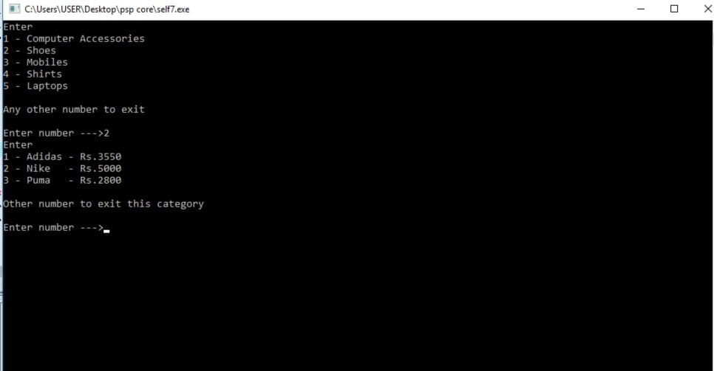

Adding other item to cart:

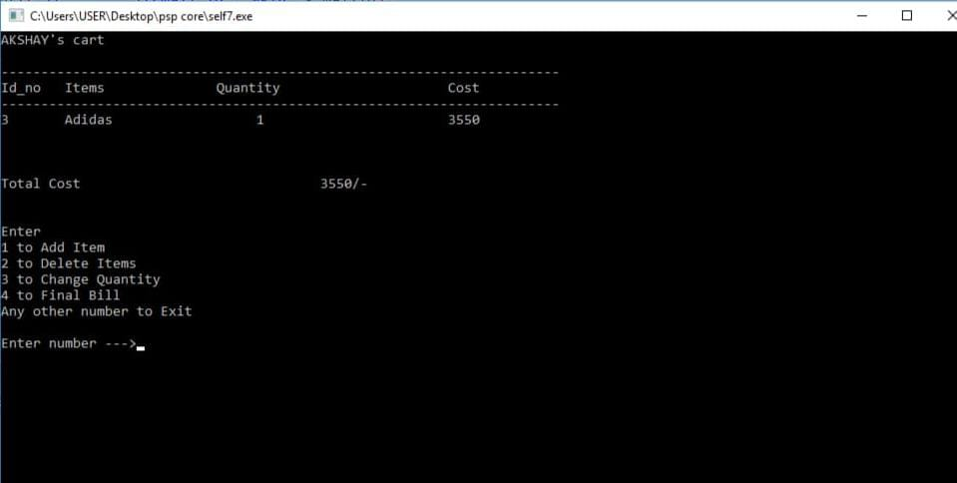

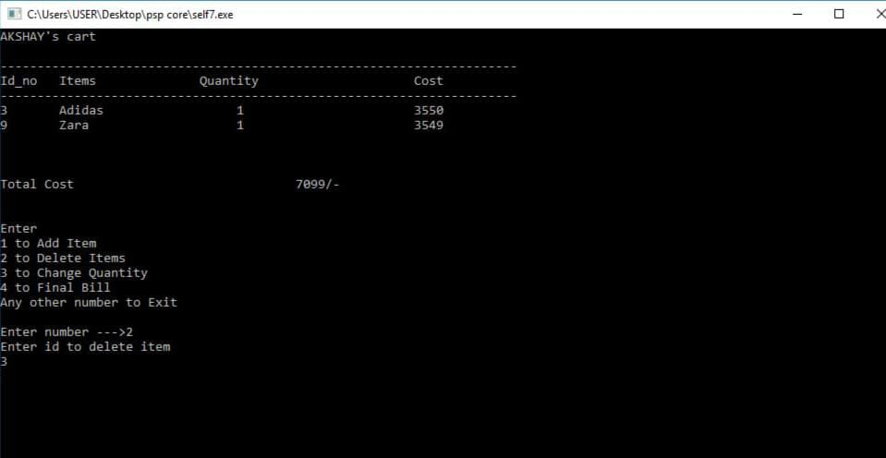

Deleting an item from the cart:

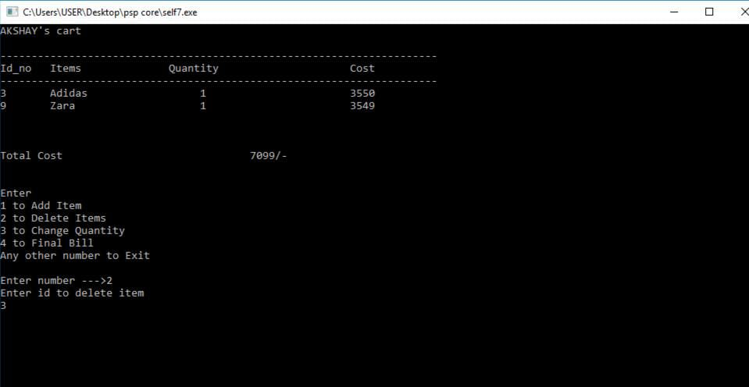

Changing quantity of item in the cart:

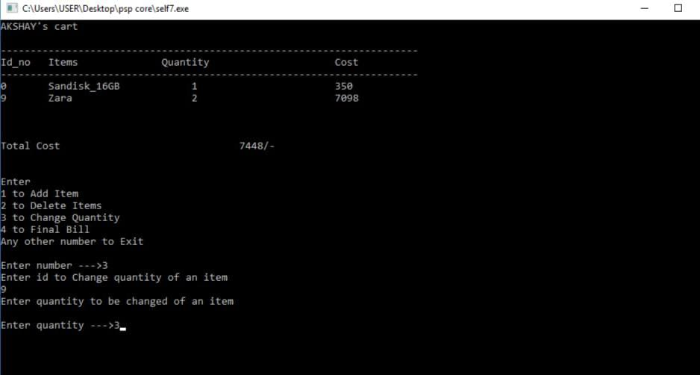

Creating a new account to order:

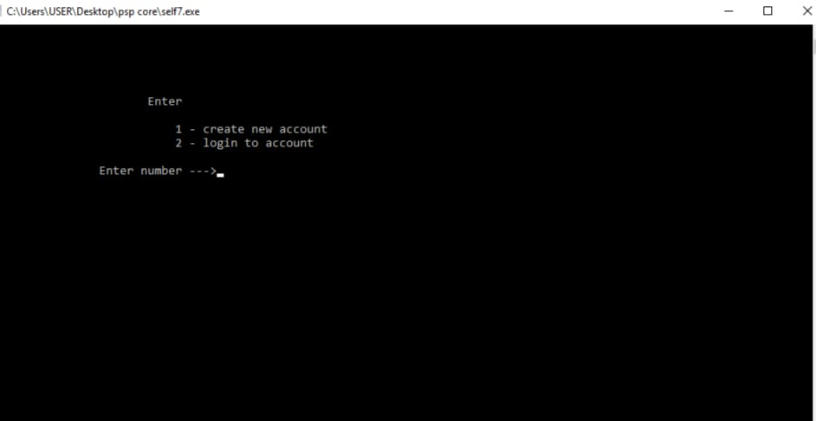

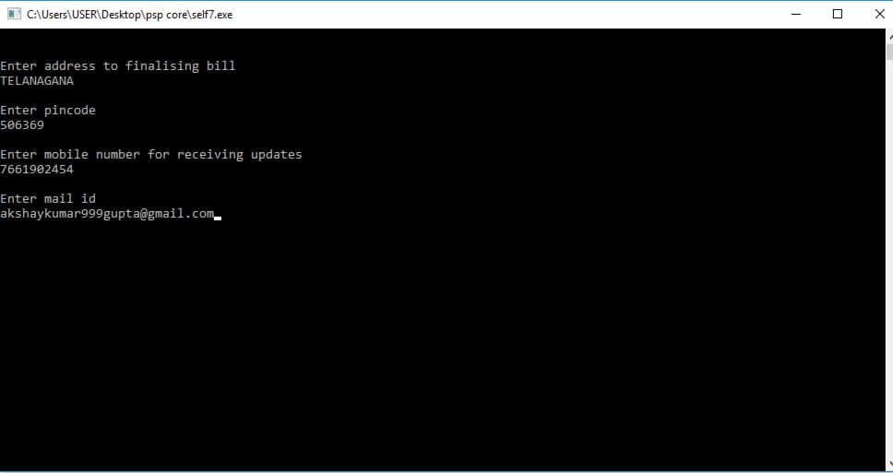

Mode of payment:

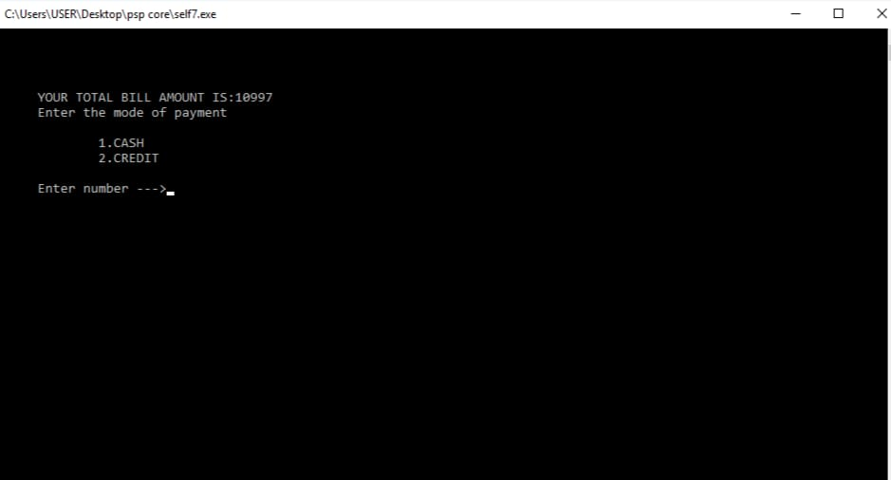

Finalising your order and Bill generation:

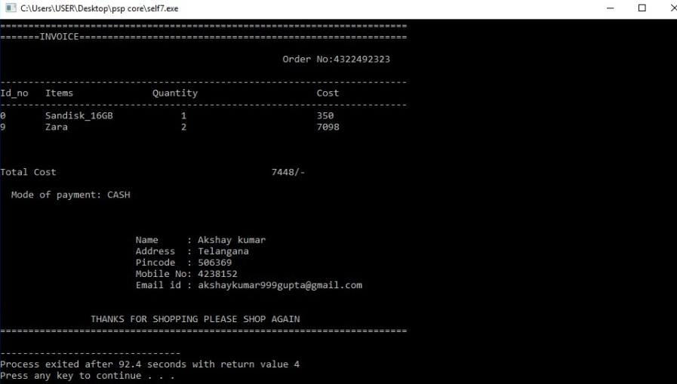

THANK YOU